Announcing NAPSA’s

2018 Annual Conference
October 14 – 17, 2018

Cincinnati Marriott RiverCenter

Covington, KY

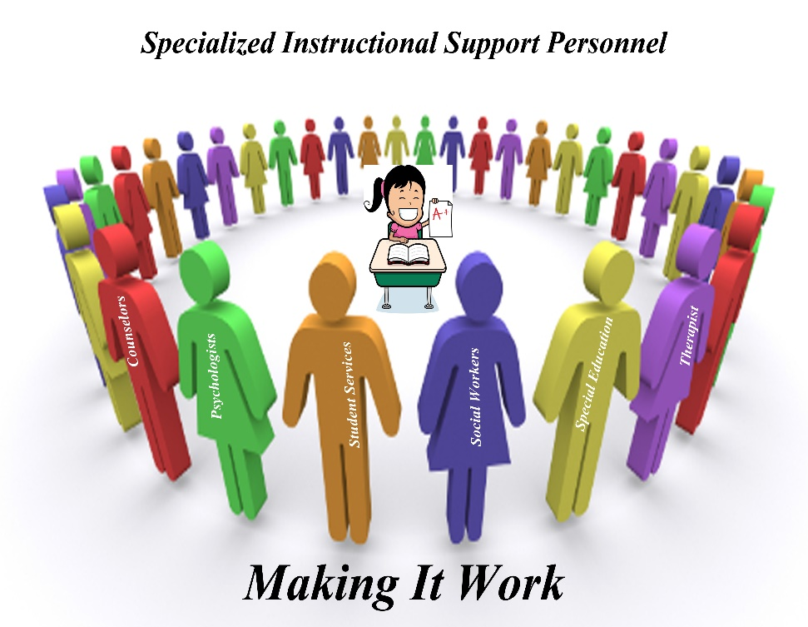

▬▬▬▬▬▬▬▬▬▬▬▬▬▬▬▬▬▬▬▬▬▬

Conference Agenda

Sunday, October 14, 2018

3:00-4:30 P.M. Conference Registration Pre-Function Area
4:30-5:00 P.M. President’s Welcome and Conference Overview Covington III

5:00 – 7:00 P.M. President’s Reception (Sponsored by Ombudsman) River View Room
▬▬▬▬▬▬▬▬▬▬▬▬▬

Monday, October 15

8:00 A.M-3:00 P.M. Registration

8:00 - 8:30 AM Registration - Coffee, Tea and Pastries Pre-Function Area

8:30 - 9:00 A.M. Opening Presentation - Kentucky’s Intern Commissioner of Education Covington III
Dr. Wayne D. Lewis, Jr.
9:00 - 10:15 - A.M. Session One – Keynote Speaker Covington III
Dr. Roger Cleveland - “Educational Equity: A Viable Approach for Student Success”
Workshop: This presentation is designed to articulate the importance of education equity and cultural responsiveness in educational settings to increase student achievement and impact school improvement initiatives. Participants will engage in activities and courageous conversations that will facilitate a deeper understanding for some and a new perspective for others for inclusive excellence. This session will lay the foundation for the implementation and application of equitable policies, practices and processes. The training will allow participants to:
●Develop strategies to implement and sustain equitable practices,
●Learn a defined set of values, principles, and behaviors, to work effectively in a diverse cultural context
●Analyze and assess barriers to inclusive excellence
●Engage in dialogue about the challenges to develop culturally responsive policies in schools and districts
●Discuss the initial steps of developing equity policies and plans

10:15 – 10:30 A.M. BREAK Pre-Function Area

10:30 – 11:45 AM Dr. Cleveland – (Continued)

11:45 – 1:00 P.M. Lunch on your Own

1:00 - 2:30 P.M. Session Two Covington III
Dr. Richard Scott - “Child Abuse Neglect and Human Trafficking"

Human trafficking is the trade of humans for forced labor, sexual slavery, or commercial sexual exploitation for the trafficker or others. It is the second-largest industry for organized crime in the world. It often happens locally, with people being trafficked they know from their own neighborhoods. This workshop will differentiate between child abuse and trafficking, identify the signs that a client has been trafficked, identify the several types of trafficking and review federal laws specific to human trafficking.

2:30 – 2:45 P.M. BREAK Pre-Function Area

2:45 - 4:45 P.M. Session Three Covington III
Dr. William Noel, Sr.- “How to Reach the “Sometimes” Hard to Reach”

Research indicated that in a single year, 1.2 million African-American students faced one (1) day of suspension from our nation’s public schools. Of that 1.2 million, nearly 55% were from districts in 13 southern states, including Virginia. In this presentation, participants will discover how Henrico County Public Schools (VA) transitioned from a traditional mindset to an instructional mindset regarding student discipline. Participants will learn about practices that address discipline disparity, and hear practical strategies to teach educators, “How to reach the (sometimes) Hard-to-Reach

6:00 –9:30 PM Networking Dinner Event (Optional) Scenic Riverboat Cruise

Attending attendees will have an opportunity to interact with their colleagues in a relaxing atmosphere, as they dine and relax on this scenic dinner and dance cruise. Music is provided by an entertaining DJ. The meal includes: Tossed salad with cucumbers & tomatoes (on salad) & accoutrements with ranch & balsamic vinaigrette dressings, rolls & butter, Carved sirloin with aujus & creamy horseradish sauce, marinated chicken, roasted marinated vegetables, mashed potatoes, vegetarian pasta, chef's choice dessert (cheesecake)

▬▬▬▬▬▬▬▬▬▬▬▬▬

Tuesday, October 16

8:30 AM - 10:00 A.M. Session One Covington III
Michael Elder - “Building & Maintaining Positive Climate & Culture: Are you a BELIEVER, TWEENER or CAVE DWELLER?”
A vibrant and sustainable climate and culture is the bedrock of any successful school district. Reinforcement of a positive, effervescent atmosphere needs to occur 24-7. It takes buy-in from every member of the school family: administrators, teachers, students, parents, community members and support staff. Employee’s fall in to 3 distinct categories: BELIEVERS, TWEENERS and CAVE DWELLERS.
This presentation will focus on how each of these individuals impact the climate and culture of a school district, and how to combat the negativity a Cave Dweller can bring. As administrators or members of a school community you can positively influence the climate and culture and grow your Tweeners to be Believers, and perhaps lure some from their Caves.
10:00 – 10:15 A.M. BREAK Pre-Function Area

10:15 – 11:45 A.M. Session Two

Christina Henagen Peer “Protecting Students from Bad Employees”
The topic is intended to deal with teachers who perform poorly (e.g., poor IEP writing, implementation errors, poor data collection, etc.) as opposed to teachers who are physically (or emotionally) harming students.

11:55 - 1:00 P.M. NAPSA Luncheon & Business Meeting Gazebo
(Included in conference fee)

1:15 - 2:45 P.M. Session Three Covington III
Dr. John Correll and Ellen Correll “Effective Leadership to Implement Change”

In this two-session workshop, the goal will be to develop an understanding of the steps and components of successful change, and the application of leadership skills needed to make it work.
- Models and Concepts of Change
- Exploration of Concepts of Leadership Needed for Change
A. Jim Collins-Level 5 Leadership
B. John Maxwell- Leadership Practices to Lead Down
C. Peter Drucker
3. Discussion of a Major Change in Current Work Life - Individual Consideration of an Area of Change in Current Job
4. Application of Change Process to Personal Professional Example - Work Through a Change Model with a Personal Example
5. Leadership Needed to Make It Happen - Refocus on Salient Components from #5
6. Conclusion and Summary

2:50 - 5:30 P.M. Session Four – Educational Field Trip – National Underground Railroad Freedom Center
“The National Underground Railroad Freedom Center is a museum in downtown Cincinnati, Ohio based on the history of the Underground Railroad. Opened in 2004, the Center also pays tribute to all efforts to "abolish human enslavement and secure freedom for all people."
It is one of a new group of "museums of conscience" in the United States, along with the Museum of Tolerance, the United States Holocaust Memorial Museum and the National Civil Rights Museum. The Center offers insight into the struggle for freedom in the past, in the present, and for the future, as it attempts to challenge visitors to contemplate the meaning of freedom in their own lives. Its location recognizes the significant role of Cincinnati in the history of the Underground Railroad, as thousands of slaves escaped to freedom by crossing the Ohio River from the southern slave states. Many found refuge in the city, some staying there temporarily before heading north to gain freedom in Canada.”
In addition to the focus on the Underground Railroad, the center provides valuable information on today’s human trafficking and modern-day slavery. Visitors will learn about today’s forms and manifestations of slavery and abolition. It is estimated that over 21 million people are enslaved throughout the world. To learn more about the center visit www.freedomcenter.org

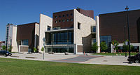
▬▬▬▬▬▬▬▬▬▬▬▬▬

Wednesday, October 17

8:00-8:30 A.M. Breakfast Buffet/ Prizes Gazebo

8:30-10:00 A.M. Session One Covington III
Dr. John Correll and Ellen Correll “Effective Leadership to Implement Change”
This workshop session will be a continuation of Tuesday’s session three.

10:00 – 10:15 A.M. BREAK Pre-Function Area

10:15 -10:45 A.M. Session Two
To Be Announced Covington III

10:50 – 11:30 Session Three Covington III
Vernice Thomas – “Bringing Back Resources to Implement What? So, What? What Now?”

11:30 Closing Remarks Covington III
Dr. Frank M. Bruno

▬▬▬▬▬▬▬▬▬▬▬▬

Conference Speakers:
Dr. Roger Cleveland “has been at the forefront of equity and inclusion initiatives for over a decade. He has served as an equity advisor, and as a moderator, keynote and presenter at over 80 various conferences, forums and symposiums promoting diversity, equity and inclusion.”
Cleveland is widely sought after for his expertise in such areas as cultural proficiency, instructional equity, implicit bias and closing opportunity gaps. He has led staff development events for many school districts, social service agencies, state educational agencies and universities and has conducted training sessions addressing equity and inclusion issues from Alaska to Mississippi.

In academia, Roger has taught at Morehead State University, University of Kentucky, Middle Tennessee State University and Kentucky State University He is currently an associate professor in the College of Education at Eastern Kentucky University. Prior to moving into higher education, Cleveland was the Director of Instructional Equity and Federal Programs for the Kentucky Department of Education.

In 2013, he received the P.G. Peeples Equity and Excellence Achievement Award from the Fayette County Equity Council for his work in improving local schools. In 2014, Cleveland was inducted into the Kentucky Civil Rights Hall of Fame. Two years earlier, he was honored by the Kentucky
Association of Blacks in Higher Education as Professor of the Year and was recognized as “Teachers Making a Difference at Eastern Kentucky University.”

Cleveland is also the associate director of the nationally recognized Black Males Working (BMW) Academy Program at First Baptist Church of Bracktown in Lexington, Kentucky. The Academy helps African American males prepare for colleges and careers through academics, leadership, mentoring, enrichment activities and college visits. He has also been actively involved with EKU’s Call Me MISTER Program, which encourages more African American males to enter the teaching profession. He was a member of the Fayette County Public Schools Equity Council until 2017.

He served two terms on the Kentucky Department of Education’s School Curriculum, Assessment and Accountability Council, and was appointed by Mayor Jim Gray to the Lexington-Urban County Human Rights Commission in 2014. Recently, Lexington-Fayette County Urban League honored Cleveland as “The Individual Champion for Diversity Award” at the League’s 48th annual Empowerment Banquet. The award recognizes an individual or business “that embraces, advocates and promotes equity and inclusion for all diverse people. He’s had audiences with North America Toyota Manufacturing Company, Ashland Oil, Valvoline and the U.S. Attorney’s Office, to name a few.

He is the president and owner of Millennium Learning Concepts Educational Consulting Company. He resides in Lexington, Kentucky with his wife, Audra and Children, Maya, Taylor and Dorian.
******
Ellen Correll has served as Superintendent in Community Consolidated School District 46 in Grayslake, Illinois for 13 years. Prior to this position, Ellen spent 28 years in Corning, New York as a special education teacher, Director of Pupil Personnel Services, Principal of an Alternative School, Principal of the Day Treatment Program and finally, Assistant Superintendent of Curriculum and Instruction.

In addition to her responsibilities in CCSD 46, Mrs. Correll has held numerous positions within the Lake County Superintendents Association, including president. She is also a coach for the Illinois School for Advanced Leadership, where she works with other superintendents from across the state.

Ellen is especially proud of the work being done in her district to provide educational consistency, making sure all students have an equitable education.

Ellen was a member of the NAPSA board from 2001 to 2007 and served as both secretary and treasurer of the organization.

******
Dr. John H. Correll has served for 12 years as Superintendent of Schools in Salt Creek School District 48, a K-8 public school district in suburban Chicago. Prior to this position, he served as Assistant Superintendent for Teaching and Learning in Glen Ellyn, IL and Director of Pupil Services in Downers Grove, Illinois. Making sure that school districts have excellent supports for student learning as well as social emotional supports to help students be successful in school has always been a high priority. John had extensive involvement with NAPSA from 2001-2007, serving as President during the 2005-6 school year. He has presented at the state and national level on program development, evaluation, leadership and change topics.

******
Michael Elder is currently the Human Resourced Director and Head Football Coach for Avon Local Schools in Northeast Ohio. A 22-year veteran of education, Mike began his career as an Intervention Specialist at Alliance High School where he was named Teacher of the Year in 1997. In 2007, Mike was named Assistant Principal at Avon High School. As a coach, his career record is 163-44. Positive leadership and culture are paramount for the success in any organization.

******

Christina Henagen Peer is the chair of the education practice group of the Cleveland law firm, Walter ǀ Haverfield. Her practice includes a wide range of areas impacting school districts, with an emphasis on issues related to serving students with disabilities. Christina routinely counsels boards of education, as well as teachers and administrators, on state and federal disability laws. She also represents school districts in special education matters before the Ohio Dept. of Education and the U.S. Dept. of Education’s Office for Civil Rights. Plus, she has considerable experience representing districts in due process proceedings under the Individuals with Disabilities Education Act (IDEA), from initial hearings to litigation in federal court. In addition to her vast work in the special education field, Christina counsels boards on student discipline, social media issues, employee issues, First Amendment matters, public records requests, and residency and custody disputes.

For the past seven years, The Best Lawyers in America® has recognized Christina in its publications. In 2017, she received the Best Lawyers ® Education Law “Lawyer of the Year” award in Cleveland.

Christina can be reached at 216-928-2918 or cpeer@walterhav.com

******
Dr. Wayne D. Lewis, Jr. is the intern commissioner of education for the state of Kentucky. On April 17, 2018, the Kentucky Board of Education named Dr. Lewis as the interim commissioner. Dr. Lewis is a University of Kentucky professor and most recently served as the executive director of educational programs with the Kentucky Cabinet for Education and Workforce Development. He has taken a leave of absence from UK and resigned his position with the Cabinet to serve as interim commissioner.

Lewis has more than 15 years of experience in public education, serving professionally in public school districts, higher education institutions and state government. He has served as an advisor to the Kentucky Board of Education, the Education & Workforce Secretary’s Designee on Kentucky’s Early Childhood Advisory Council (ECAC) and chair of Kentucky’s Charter Schools Advisory Council. His research, writing and teaching encompass the areas of education policy and politics, human capital and human resources management in education organizations.

“I am incredibly humbled and excited to serve the Commonwealth in this position, and pledge to work every day on behalf of all the students and families across Kentucky, Lewis said. “We need to refocus the conversation on kids and on improving education for them. Our children need to be our number one priority.”

Dr. Lewis completed an undergraduate degree in Criminal Justice at Loyola University New Orleans. He earned a master’s degree in Urban Studies with a concentration in Public Administration at The University of Akron, and a Ph.D. in Educational Research and Policy Analysis with a cognate in Public Administration at North Carolina State University. He serves on the ministerial team at Wesley United Methodist Church in Lexington and is a member of Phi Beta Sigma Fraternity, Inc.
Dr. Lewis is a native of New Orleans, LA, and has called Kentucky his home since 2009. He is married to an educator and has a young daughter.

******
Dr. William Noel, Sr. is the Director of Student Support & Disciplinary Review Office in the Henrico County Public Schools (VA). “The two most important days of your life are the day you were born, and the day you find out why.” This quote by Mark Twain perfectly captures Dr. William Noel’s personal calling and passion for working for children. That higher calling and passion is “why” Dr. Noel remains committed to being an influential role model for all students, but especially for our marginalized students. Dr. Noel encourages anyone to pursue their passion(s), or to #Discover Your Why. Dr. Noel emphasizes the importance of connecting with our students by establishing genuine relationships and being transparent & honest. He will be the first person to debate that knowing WHO we teach is more important than WHAT we teach.

After graduating from the University of Virginia in 1991, Dr. Noel began this exciting journey first in Caroline County as a substitute teacher, then an Alternative Education teacher, Social Studies teacher and coach. In 2004, he was hired by Hanover County Public Schools as an Assistant Principal after earning his M.Ed. from Virginia Commonwealth University (VCU).

Because Dr. Noel truly believes Knowledge is Power, he returned to VCU, and in 2014 graduated with his Ed.D. in Leadership. That same year, he was hired as Director with Henrico County Public School, the position he currently holds. When asked by a colleague if he was going to miss teaching now that he is an administrator; Dr. Noel replied, “I will always be a teacher - just no longer from a classroom.”

******
Dr. Richard Scott is currently employed with the Maryland State Department of Education as a School Counseling Specialist in the Division of Student, Family, and School Support. He is the lead person to the College Board and postsecondary initiatives. As one of the lead persons in the Student Services Branch, he coordinates Maryland’s student services monitoring process and provides leadership for the school counseling program. He is a native of Baltimore, Maryland. He was educated in Baltimore City Public Schools. For eight years, he was a home and hospital teacher for students with chronic illnesses in Baltimore City. He became very sensitive to the needs of students who had diverse medical and emotional challenges but had the desire to be academically successful. He has extensive training and experience in school, biblical, and clinical counseling. He has served on several scholarship committees, state, and national professional organizations, including NAPSA. He has recognized the challenges, barriers, and needs of students who desired to pursue career goals or postsecondary opportunities. He has worked with families, students, and schools to identify resources to assist students. He is also a licensed clinical professional counselor (LCPC). This also provides another opportunity to assist families and students. He believes in helping students to reach their destiny by exploring and pursuing their goals.

******

♦♦♦♦♦♦

Join your Colleagues at the Cincinnati Marriott RiverCenter
_______________________________________________________

NAPSA 2018 will meet your needs offering unmatched quality
in a personal environment.

Register Now!

- President’s Reception on Sunday
- Business Luncheon on Tuesday
- Breakfast on Wednesday

Above are included in your registration.

Registration fee for members have not increased since 2008

Take advantage of early registration rates and utilize FY18 funds!

♦♦♦♦

Offering Reasonable Room Rates

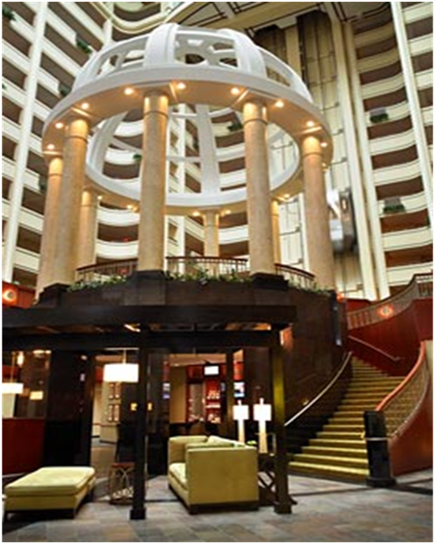

Marriott Cincinnati at RiverCenter Lobby & Gazebo

**Hotel Reservations**

The Cincinnati Marriott RiverCenter is offering a special rate of $145. To insure the NAPSA room rate, place your reservations by Sunday September 23, 2018. The hotel has created a personalized NAPSA website to make your reservations at:

https://aws.passkey.com/go/napsaoct2018

The other option is to call 800-228-9290 or 859-261-2900 and identify yourself as a part of the NAPSA group. To insure the special rate, make your reservations by Sunday, September 23, 2018. A limited number of rooms are reserved so, make your reservations as early as possible.

Transportation

From Cincinnati Northern Kentucky Airport (CVG)

► There is an Executive Airport Shuttle to and from the airport. They pick up directly at the airport
► $26.00 1-way or $40.00 round
► They do not need any prior arrangements made, but you are welcome to call them if you have questions.
► The Executive Airport Shuttle phone number is 513-352-2135

