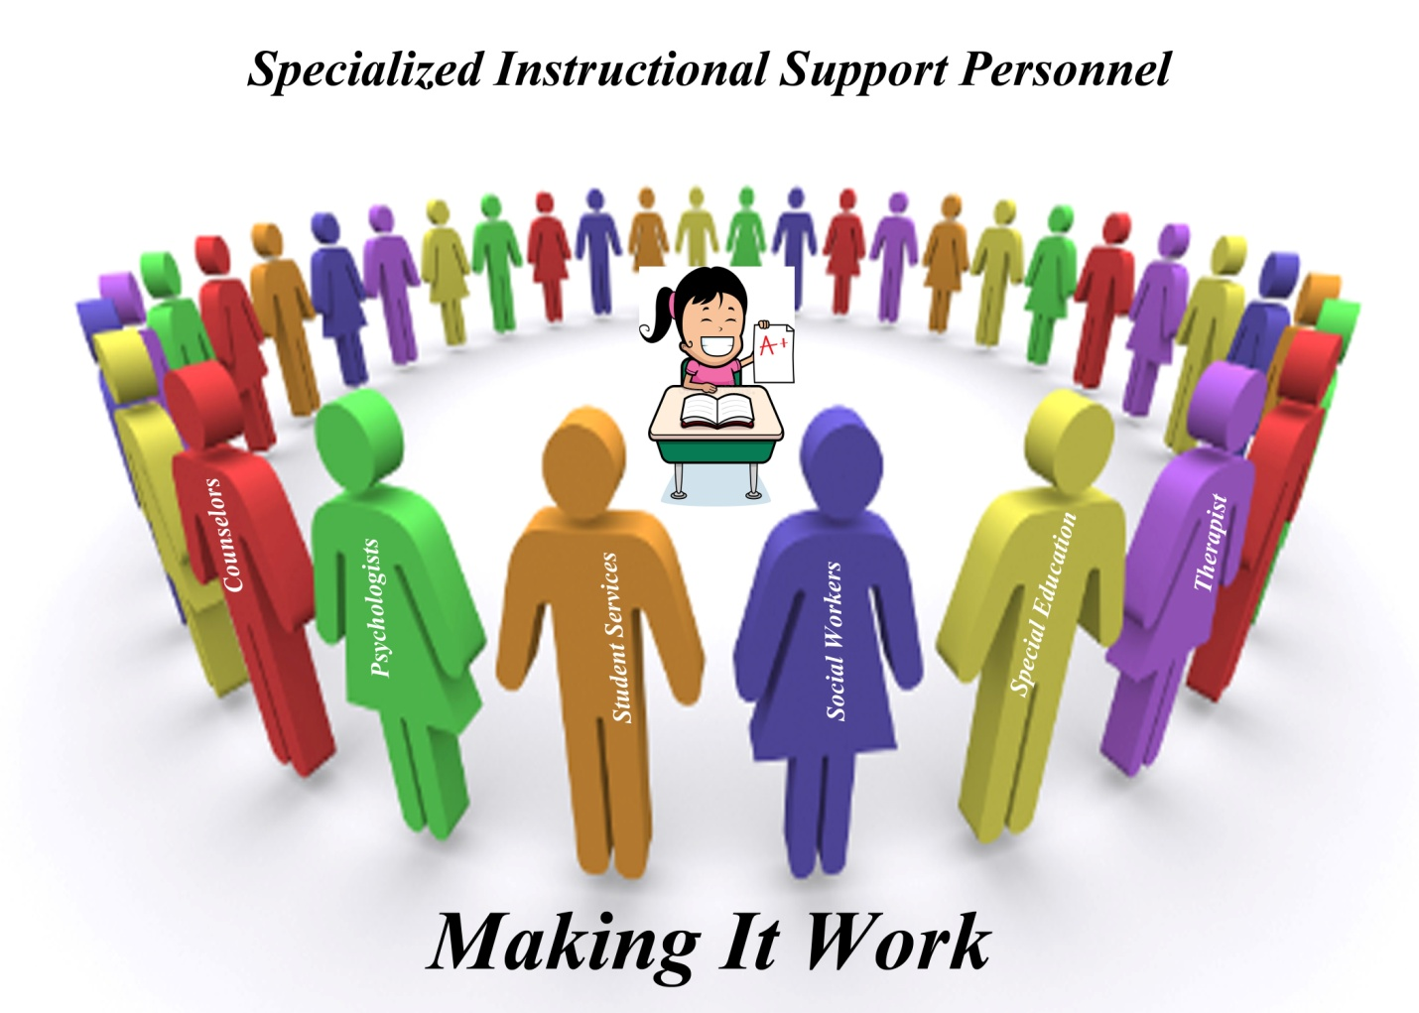

Human trafficking is a form of modern slavery—a multi-billion dollar criminal industry that denies freedom to 20.9 million people around the world. And no matter where you live, chances are it's happening nearby. From the girl forced into prostitution at a truck stop, to the man discovered in a restaurant kitchen, stripped of his passport and held against his will. It can also encompass providing a spouse in the context of forced marriage, or the extraction of organs or tissues, including for surrogacy and ova removal. All trafficking victims share one essential experience: the loss of freedom. Human trafficking is a crime against the person because of the violation of the victim's rights of movement through coercion and because of their commercial exploitation
Although slavery is commonly thought to be a thing of the past, human traffickers generate hundreds of billions of dollars in profits by trapping millions of people in horrific situations around the world, including here in the U.S. Traffickers use violence, threats, deception, debt bondage, and other manipulative tactics to force people to engage in commercial sex or to provide labor or services against their will. While more research is needed on the scope of human trafficking, below are a few key statistics:
- The International Labour Organization estimates that there are 40.3 million victims of human trafficking globally.
  - 81% of them are trapped in forced labor.
  - 25% of them are children.
  - 75% are women and girls.
- The International Labor Organization estimates that forced labor and human trafficking is a $150 billion industry worldwide.
- The U.S. Department of Labor has identified 139 goods from 75 countries made by forced and child labor.
- In 2016, an estimated 1 out of 6 endangered runaways reported to the National Center for Missing and Exploited Children were likely child sex trafficking victims.
  - Of those, 86% were in the care of social services or foster care when they ran.
- There is no official estimate of the total number of human trafficking victims in the U.S. Polaris estimates that the total number of victims nationally reaches into the hundreds of thousands when estimates of both adults and minors and sex trafficking and labor trafficking are aggregated.
Human Trafficking Facts:
- Human trafficking ranks 2nd to drug trafficking as the most lucrative terms of criminal activity.
- 100, 000 American children are at high risk for trafficking into the sex industry each year.
- One study estimates as many as 325,000 children in the U.S., Canada, and Mexico are at risk each year for becoming victims of sexual exploitations.
- Of the 100,00 to 300,00 American children who are sex trafficked, 1/3 of these youth are boys.
- 13 is the average age children are the first targeted by traffickers for involvement in commercial sex.
- Pimps prey on victims as young as 12 to 14 years old.
- A history of physical and sexual abuse is often common among victims.
- One study estimates 30% of shelter youth and 70% of street youth are victims of commercial sexual exploitation. They may engage or be coerced into prostitution for “survival sex” to meet daily needs for food, shelter, or drugs.
- 75% of child victims engaged in prostitution are under the control of a pimp.
Who Are The Victims? Individuals who have experienced violence and trauma in the past are more vulnerable to future exploitation, as the psychological effect of trauma is often long-lasting and challenging to overcome.
- Any person targeted and exploited by another into labor or commercial sex.
- Labor trafficking is widespread and can include private domestic servitude as well as larger-scale operations such as agricultural work/or sweatshops.
- Sex trafficking includes exploitation through prostitution, pornography and other forms of explicit sexual performance.
- Pimps are predators who seek out vulnerable victims, particularly runaways or children experiencing trouble at home. They know these children have emotional and physical needs they perceive are not being met and use this to their advantage.
- Pimps are willing to invest a great deal of time and effort in their victim to break down a victim’s natural resistance and suspicion-buying them gifts, providing a place to stay, promising a loving relationship-before revealing their true intent.
Who Are The Traffickers?
- Known as pimps, are those persons who profit by receiving cash or other benefits in exchange for the sexual use of a minor by another person.
- Traffickers employ a common language to provide a basis of understanding and to facilitate transactions between traffickers/pimps. Below is a sampling of terms used by pimps in the sex trafficking of children:
- A “circuit” or “track” is defines area known for prostitution activity.
- A “ho line” is a loose network of communication between pimps, chiefly by
phone. It used to trade, buy, and sell women and children for sex.
- The”kiddie stroll” or “runway” is an area of the track featuring kids under 16, and often much younger’
- The process of “seasoning” involves the combination of psychological manipulation, intimidation, gang rape and sodomy, beatings or deprivation of food and sleep, cutting off from family, friends, and other sources of support. The purpose is to break down a victim’s resistance and ensure that he or she will do anything they are told.
- A “stable” is a group of prostituted girls under the control of a single trafficker or pimp.
- “Bottom girl” : The girl in a stable who is tasked by the pimp with supervising the others, reporting rule violations, and often helping to impose punishment on them.
- “The Game” is slang for the environment and established rules of trafficking/pimping. It is handed down to traffickers/pimps through various means.
- Pimps have a significant number of psychopathic qualities.
How does Human Trafficking Affect Our Schools?
Trafficking can involve school-age children-particularly those not living with their parents-who are vulnerable to coerced labor exploitation, domestic servitude, or commercial sexual.
Sex traffickers target children because of their vulnerability and gullibility, as well as the market demand for young victims. Those who recruit minors into prostitution violate federal anti-trafficking laws, even if there is no coercion or movement across state lines. The children at risk are not just high school students-studies demonstrate that pimps prey on victims as young as 12. Traffickers have been reported targeting their minor victims through telephone chat-lines, clubs, on the street, through friends, and at malls, as well as using girls to recruit other girls at schools after-school programs.
Traffickers are brutal, and victims are often subjected to serious, life-altering manipulation, and control through the use of threats of violence, physical, sexual, or emotional abuse, and withholding of basic necessities. Many children do continue to attend school while being trafficked, and as such, are in contact with school personnel on a regular basis. This means that because of your role as an education professional, you may be in a position to identify and report human trafficking, thus facilitating the child’s rescue by law enforcement.
How Do I Identify a Victim of Human Trafficking?
A victim:
- Has unexplained absences from school for a period of time, and is therefore a truant
- Demonstrates an inability to attend school on a regular basis
- Chronically runs away from home
(ONE OUT OF EIGHT endangered runaway youths is likely a victim of human trafficking.
—National Center for Missing and Exploited Children)
- Makes references to frequent travel to other cities
- Exhibits bruises or other physical trauma, withdrawn behavior, depression, or fear
- Lacks control over her or his schedule or identification documents
- Is hungry-malnourished or inappropriately dressed (based on weather conditions or surroundings)
- Shows signs of drug addiction
Additional signs that may indicate sex-related trafficking include:
- Demonstrates a sudden change in attire, behavior, or material possessions (e.g., has expensive items)
- Makes references to sexual situations that are beyond age-specific norms
- Has a “boyfriend” who is noticeably older (10+ years)
- Makes references to terminology of the commercial sex industry that are beyond age specific norms; engages in promiscuous behavior and may be labeled “fast” by peers.
Everyone who is part of the school community—administrators, teachers, bus drivers, maintenance personnel, food service staff, resource officers, and other school community members—has the potential to be an advocate for child victims of human trafficking, but, first, school community members must learn the indicators of the crime, its warning signs, and how to respond when a student is an apparent victim.
Though they play a crucial role, school personnel cannot, and should not, address these complex issues alone. Effectively responding to child trafficking demands increased awareness and a clearly defined course of action, supported by collaboration with child protective services, law enforcement, social services, and community-based service providers.

A Form of Abuse
Human trafficking is defined as a form of abuse or neglect in several states. Under Texas Family Code, Section 261.001. All individuals have a duty to immediately report suspected abuse or neglect to law enforcement or the Texas Department of Family and Protective Services (DFPS), but Texas Family Code, Section 261.101, requires education professionals to do so within 48 hours of suspecting the abuse or neglect. As a school employee, your training on abuse and neglect provide a foundation for you to recognize and report suspected human trafficking.
Maryland Human Trafficking Task Force (MHTTF) was formed in 2007 to address the growing prevalence of human trafficking in Maryland. The goal of the task force is to engage a multi-disciplinary team in discovering and rescuing victims of trafficking, while identifying and prosecuting offenders. MHTTF serves as the lead investigative. Prosecutorial, and victim services-coordinating body for anti-trafficking activity in the State of Maryland. In 2012, the Maryland General Assembly included human trafficking in the State’s Child Abuse and Neglect Law.
Maryland State Department of Education partnered with MHTTF to develop human trafficking training and informational material to disseminate to staff. Specialized training was provided for Pupil Personnel Workers, Health Services, Psychological Services, Social Workers and School Counselors. The Department equips its teachers, as mandatory reporters, through various trainings. The Department collaborates with various groups to provide awareness and trainings: PTA’s, student councils, custodians, bus drivers and food services.

Resources
National Human Trafficking Resource Center Hotline: 1-888-373-7888
Maryland Human Trafficking: www.mdhumantrafficking.org
U.S. Department of State. (2013). Trafficking in persons report 2013. Washington, DC: Author. Available at http://www.state.gov/j/tip/rls/tiprpt/2013/
National Human Trafficking Resource Center: www.traffickingresourceenter.org

U.S. Department of Health and Human Services, Administration for Children and Families www.acf.hhs.gov/endtrafficking
U.S. Department of Homeland Security Blue Campaign http://www.dhs.gov/blue-campaign/share-resources
Runaway and Homeless Youth Training and Technical Assistance Center http://www.rhyttac.net/resources/document/human-trafficking-resource-list

form of modern slavery—a multi-billion dollar criminal

